# VLOOKUP core concepts

Functions can be used to quickly find information and perform calculations using specific values. In this reading, you will learn about the importance of one such function, VLOOKUP, or Vertical Lookup, which searches for a certain value in a spreadsheet column and returns a corresponding piece of information from the row in which the searched value is found.

A VLOOKUP function is available in both Microsoft Excel and Google Sheets. Let's start by looking at an example of the way VLOOKUP is used and the general syntax associated with it in Google Sheets. (You can refer to the resources at the end of this reading for more information about VLOOKUP in Microsoft Excel.)



## Sample usage



Let's break down the syntax.



### search_key

* The value to search for.
* For example, 42, "Cats", or I24.

### range

* The range to consider for the search.
* The first column in the range is searched for the key specified in search_key.

### index

* The column index of the value to be returned, where the first column in range is numbered 1.
* If index is not between 1 and the number of columns in range, #VALUE! is returned.

### is_sorted

* Indicates whether the column to be searched (the first column of the specified range) is sorted. TRUE by default.
* It’s recommended to set is_sorted to FALSE. If set to FALSE, an exact match is returned. If there are multiple matching values, the content of the cell corresponding to the first value found is returned, and #N/A is returned if no such value is found.
* If is_sorted is TRUE or omitted, the nearest match (less than or equal to the search key) is returned. If all values in the search column are greater than the search key, #N/A is returned.

## When do you need to use VLOOKUP?

Two common reasons to use VLOOKUP are:

* Populating data in a spreadsheet
* Merging data from one spreadsheet with data in another

### Example of populating data

Populating data is a great example of why you'd want to use VLOOKUP. Have you ever had data that exists in two spreadsheets, but you need both spreadsheets to solve the problem? VLOOKUP can connect your two sheets together, on a matching column, to populate one single sheet.

You may click the link below and select "Use Template" to work with the spreadsheets described.

Link to template:  [VLOOKUP Example](https://docs.google.com/spreadsheets/d/10tEwQxOU3EbAXJfRwDUWuWFx2oytjY8YUc54U5Y7TfY/template/preview).

Or, if you don’t have a Google account, download the spreadsheet from the attachment below.

[VLOOKUP Example.xlsx](https://d3c33hcgiwev3.cloudfront.net/R5CJjxgJR9WQiY8YCTfVUg_aa7853f630d8463180e8dba18a963794_VLOOKUP-Example.xlsx?Expires=1623283200&Signature=QS9xkSmSumSuZjRwpb2TJaJvYL9Gyc87b6w4KMdfi5ux7Ihzpjtna0CKAv31bHSxKuQ~VVQMEKcLv3CAcpE74gbQQcmKDwgfpIZVoqNUJsPf6gtZ09eLGCUR~VWz3MQ~w3ZkmZ-kZ1YhBJw2A-aHNbY2yd8PaTzgx0I3j0zOJgg_&Key-Pair-Id=APKAJLTNE6QMUY6HBC5A)

The Employee Rates spreadsheet contains the pay rates for employees.

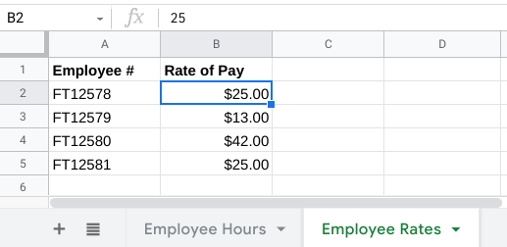

The Employee Hours spreadsheet contains the hours worked by employees. You can use VLOOKUP to pull in the rate of pay from the Employee Rates spreadsheet into the Employee Hours spreadsheet. Then, you can use the hours and the rates pulled in to calculate the final pay for each employee. Notice the VLOOKUP formula you would use to pull in the rate of pay from the Employee Rates spreadsheet:

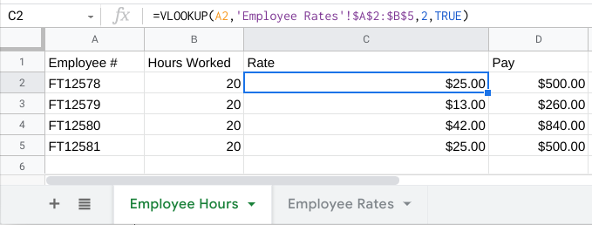

### Example of merging data

If the Employee Rates spreadsheet also had store location information that needed to be merged into the Employee Hours spreadsheet, VLOOKUP would also be helpful.

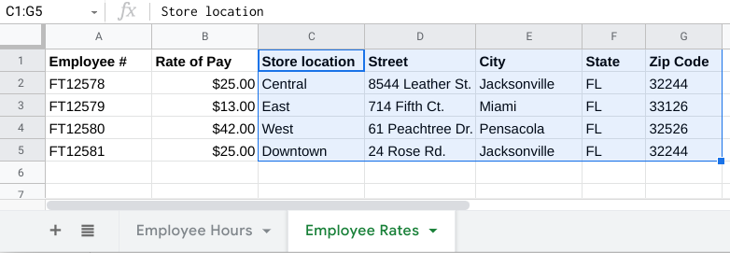

Important note: The following steps for Google Sheets will slightly differ in Microsoft Excel, but can still be generally applied.

Step 1: In the Employee Rates spreadsheet, create new column headers for Store Location, Street, City, State, and Zip Code, and enter the data as shown above.

Step 2: Click the Employee Hours tab and create the Store Location, Street, City, State, and Zip Code column headers to the right of the Pay column.

Step 3: For the first employee in the Employee Hours spreadsheet, copy the VLOOKUP formula from the Rate column, paste it in the Store Location column, and adjust the following:

* Change the search key back to A2
* Change the range from $A$2:$B$5 to $A$2:$G$5
* Increment the index from 2 to 3

Below is the VLOOKUP formula you would use for Store Location for the first employee:

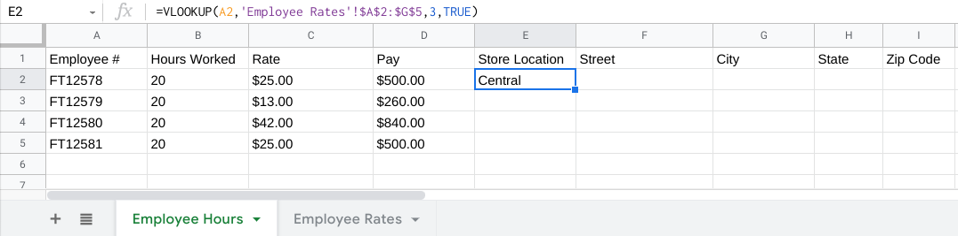

Step 4: Copy the formula to the cells in the rest of the row, and adjust the following:

* Change the search key back to A2
* Increment the index by 1 each time to move to the right by a column; the final column has an index of 7 as shown below

Below is the VLOOKUP formula for the last cell in the row:

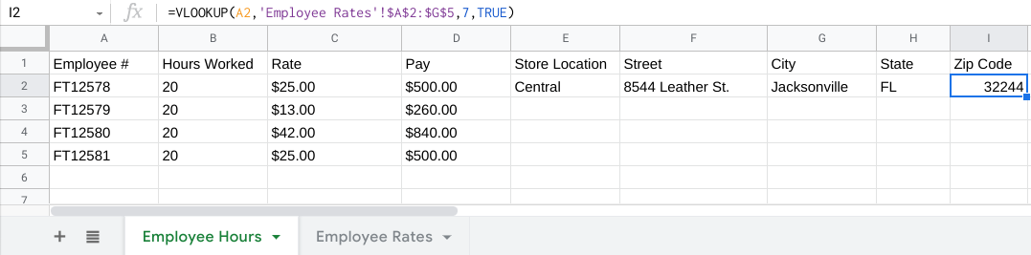

Step 5: Copy the formulas in the row for the first customer to populate each of the customer rows below it.

Below is the VLOOKUP formula for Store Location for the second employee (copied and pasted from the previous row). Notice that the search key changed from A2 changed to A3:

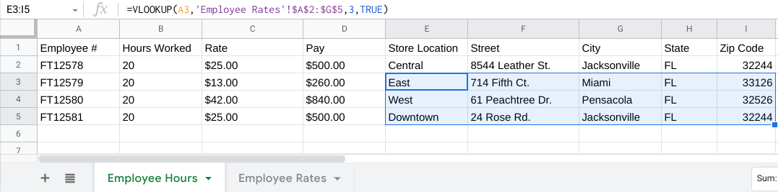

Step 6: Copy the merged data (E2:I5), and then right-click to select the Paste special > Values only option to paste the values back into the same cells.

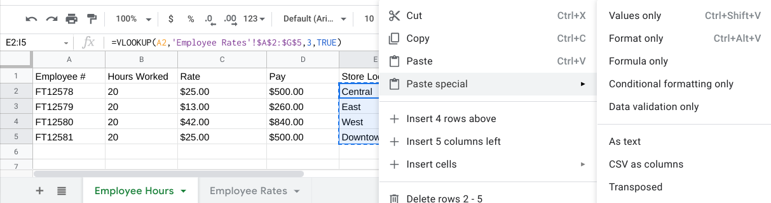

This completes the merging of the data in the Employee Hours spreadsheet. Copying and pasting the data as Values only removes the VLOOKUP formulas from the merged data.

## Helpful VLOOKUP reminders

* TRUE means an approximate match, FALSE means an exact match on the search key. If the data used for the search key is sorted, TRUE can be used.
* You want the column that matches the search key in a VLOOKUP formula to be on the left side of the data. VLOOKUP only looks at data to the right after a match is found. In other words, the index for VLOOKUP indicates columns to the right only. This may require you to move columns around before you use VLOOKUP.
* After you have populated data with the VLOOKUP formula, you may copy and paste the data as values only to remove the formulas so you can manipulate the data again.

## VLOOKUP resources for Microsoft Excel

* [H​ow to use VLOOKUP in Excel](https://support.microsoft.com/en-us/office/vlookup-function-0bbc8083-26fe-4963-8ab8-93a18ad188a1): This tutorial includes a video to help you get a general understanding of how the VLOOKUP function works in Excel, as well as practical examples to look through.
* [VLOOKUP in Excel tutorial](https://www.youtube.com/watch?v=d3BYVQ6xIE4): Follow along in this video lesson and learn how to write a VLOOKUP formula in Excel and master time-saving useful tips and tricks.
* [23 things you should know about VLOOKUP in Excel](https://exceljet.net/things-you-should-know-about-vlookup): Explore this list of 23 VLOOKUP facts as well as challenges you might run into, and start to learn how to master them.
* [How to use Excel's VLOOKUP function](https://edu.gcfglobal.org/en/excel-tips/how-to-use-excels-vlookup-function/1/): This article shares a specific example around how to apply VLOOKUP in your searches.
* [VLOOKUP in Excel vs Google Sheets](https://infoinspired.com/sheets-vs-excel-formula/vlookup-formula-in-excel-and-google-sheets/): This guide offers a VLOOKUP comparison of Excel and Google Sheets.